Scalar Visualization

# **Color mapping**

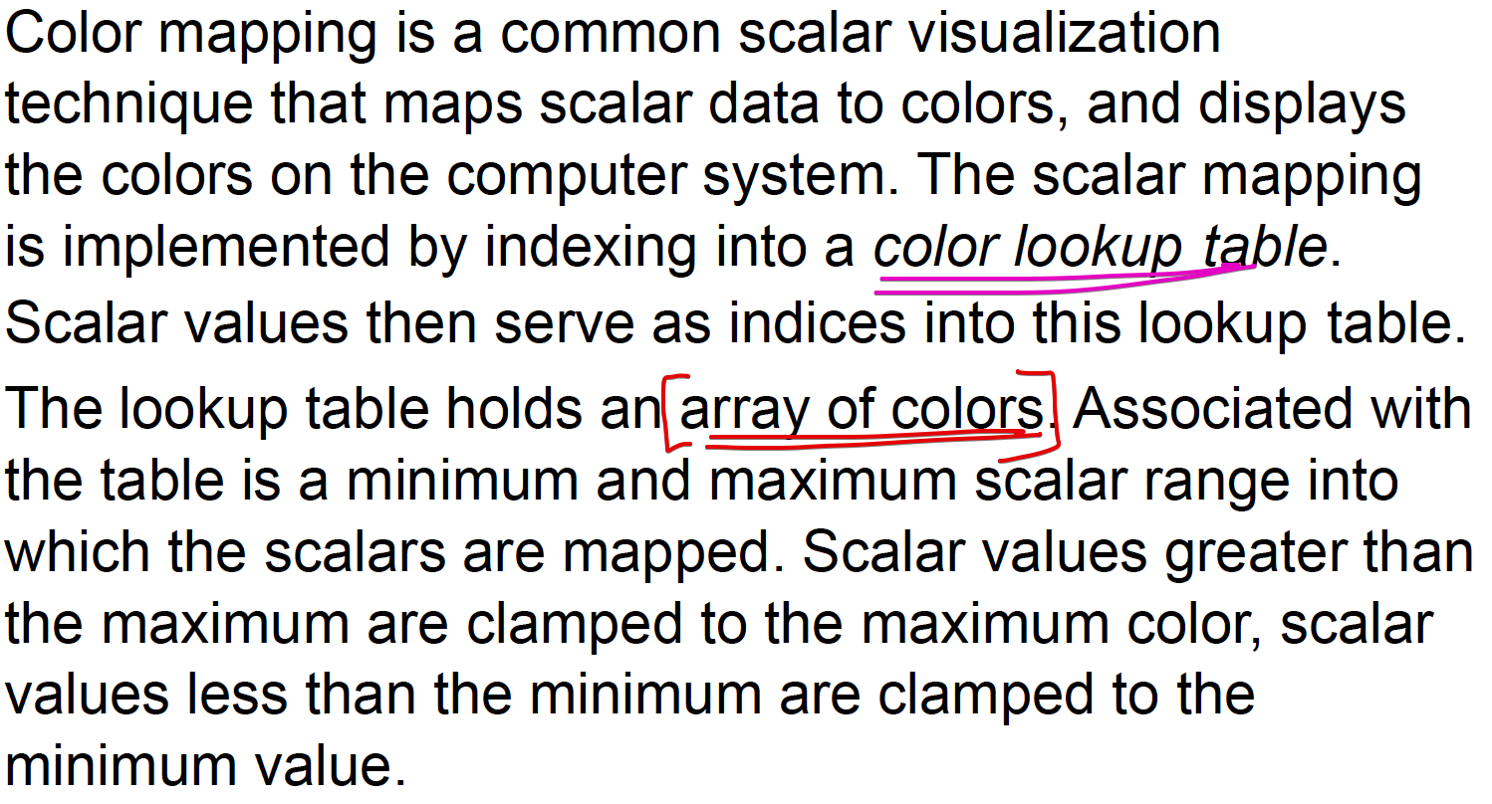

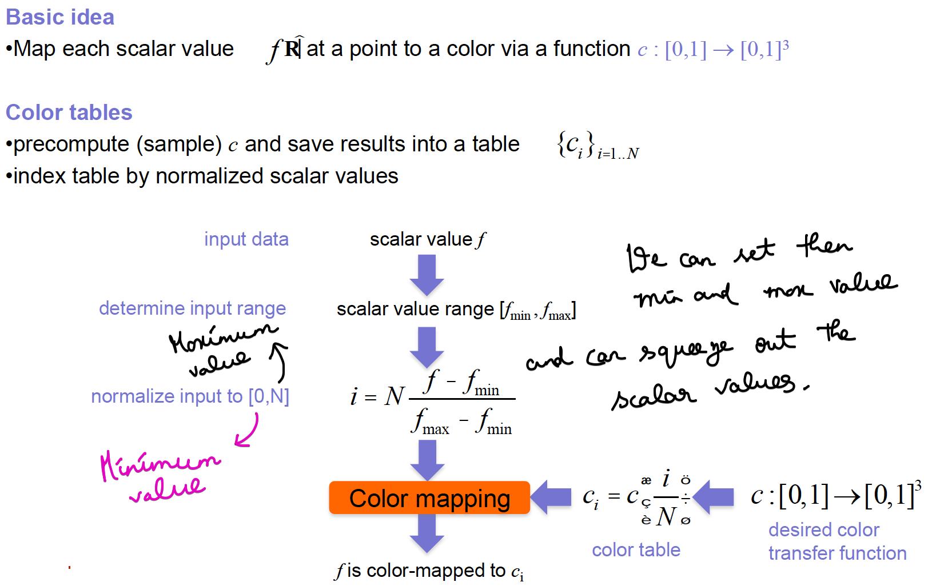  
Color look-up table

Scalar values 🡪 Max and Min (fmax and fmin)

These scalar values are normalized 🡪 will get a range  
Will get a maximum and minimum value.

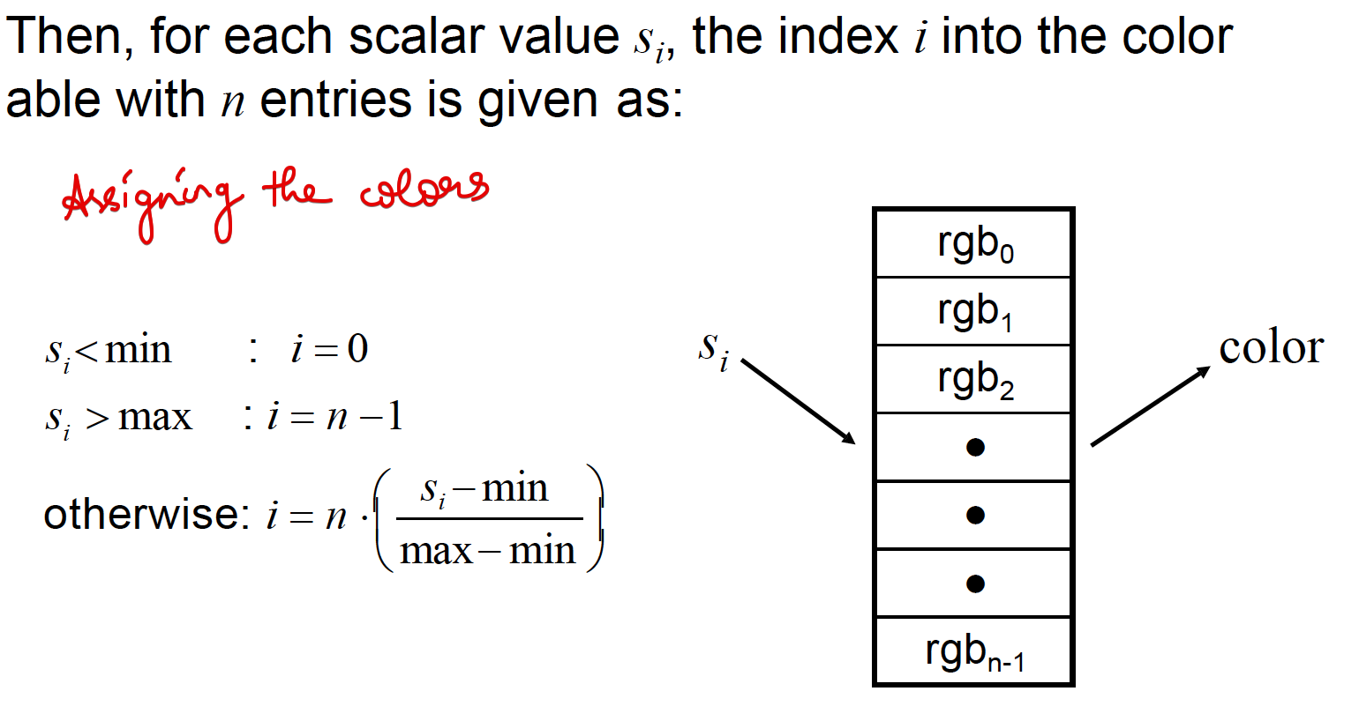

## **Transfer Functions**

Alternative methods to give color, apart from simply looking and applying from the look-up table.

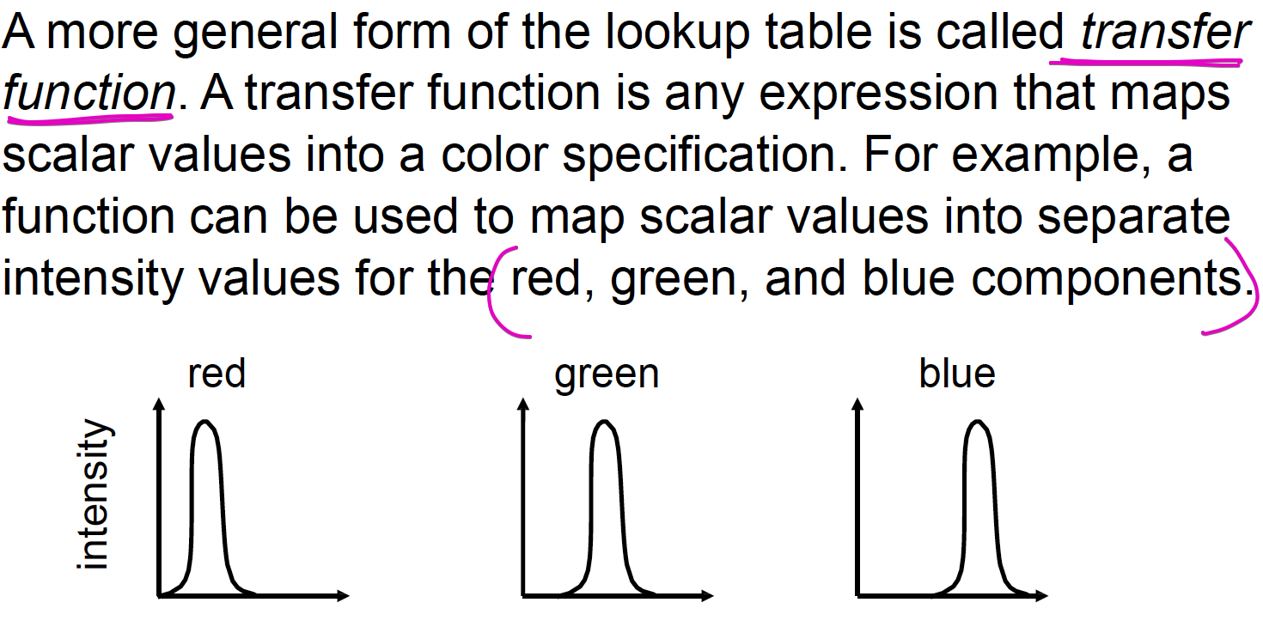

## **Color map Design**

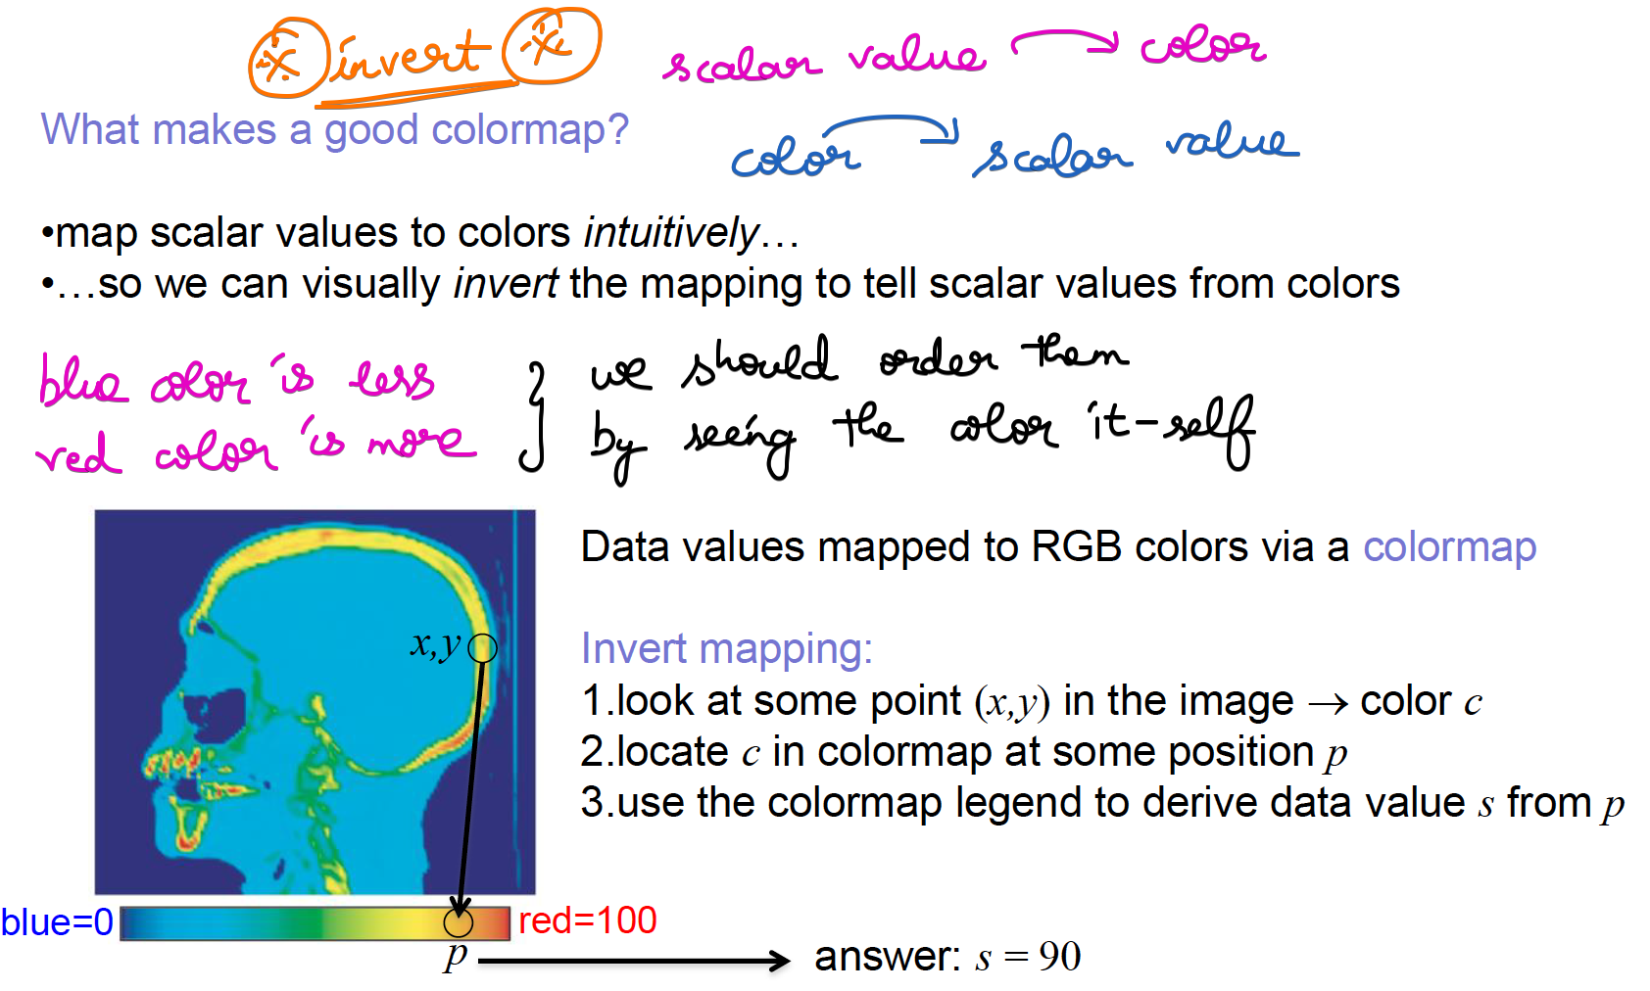

**

fabs 🡪 floating absolute value

## **Grey-Scale Color map**

Widely used in Medical scans

Black 🡪 min  
White 🡪 max  
Grey 🡪 middle

The brightness level shows the difference.

Advantages:

* Easier to follow and focus, because of only 2 variations.
* Less confusing. Easy to spot the difference.
* Ordering of color is very natural (i.e from dark to bright).
* Different devices have different pixels to display. There is no rendering problem, since black and white are less sensitive to color.

Dis-Advantages:

* Cannot able to figure out between 2 gray scale values, since there might be several shades of gray color.

## **Two-Color**

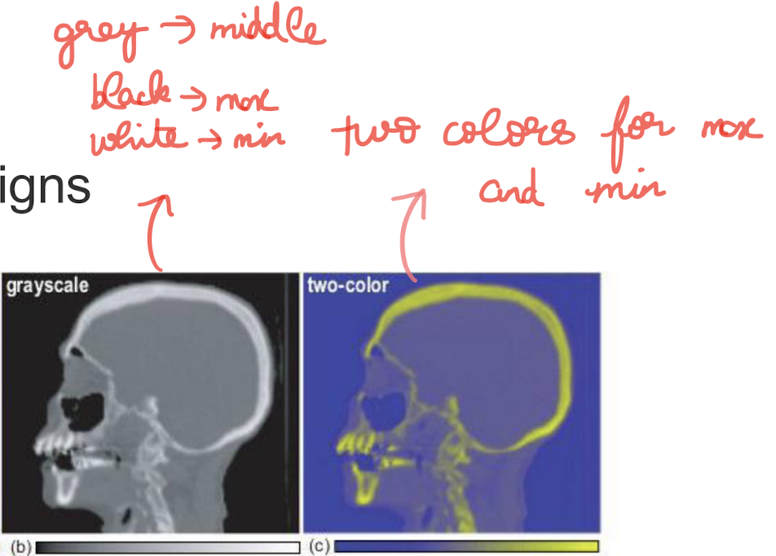

Only two colors are present (2-hue) , no need of ordering.  
1 color 🡪 maximum and the other color 🡪 minimum.

## **Heatmap**

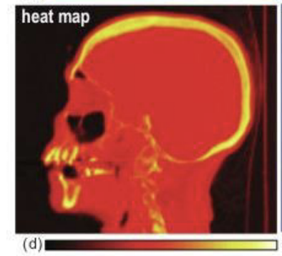

* To display the temperature. Heated Body map.
* Yellow to white 🡪 max values / high temperature.  
  Black 🡪 min values / low temperature.  
  Red to orange 🡪 middle remaining values / intermediate temperature.
* Similar to rainbow colormap, but the range of colors is less.
* Bit more colors than 2_hue color maps.
* Heat map may be better if ordering of colors as more colors than   
  2-Hue but less than rainbow.

## **Diverging**

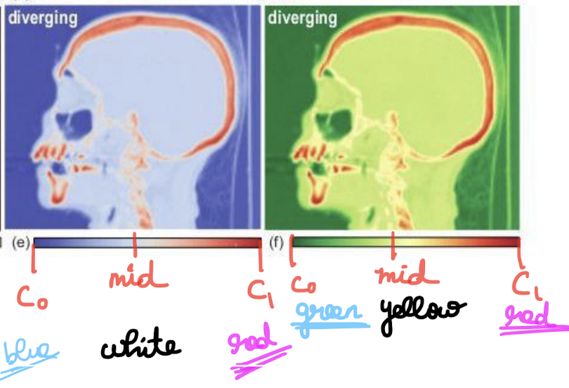

Instead of 2 Hues we are using 3 Hues  
1) one color 🡪 middle values  
2) low-color 🡪 lower range  
3) high-color 🡪 higher range

Interpolate between colors i.e) low-color ; color-high

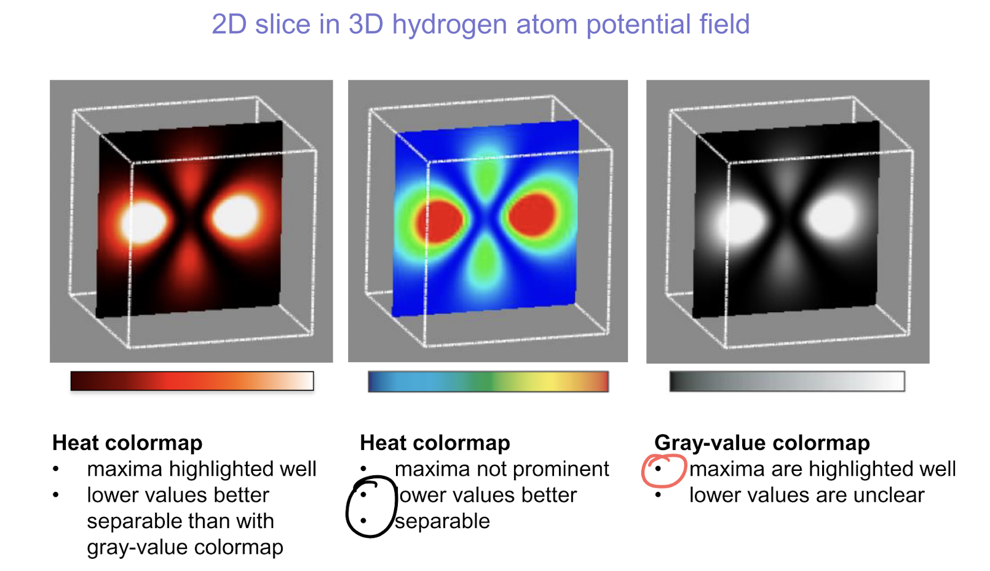

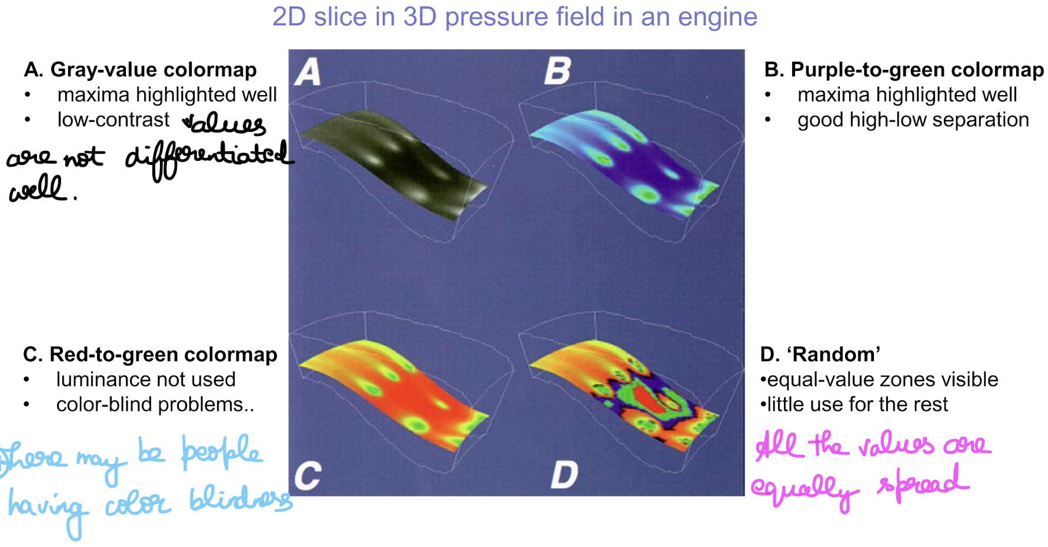

## **Color Map Design Techniques**

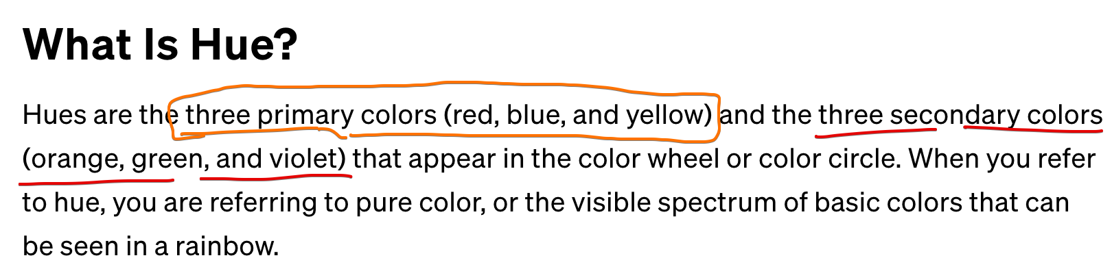

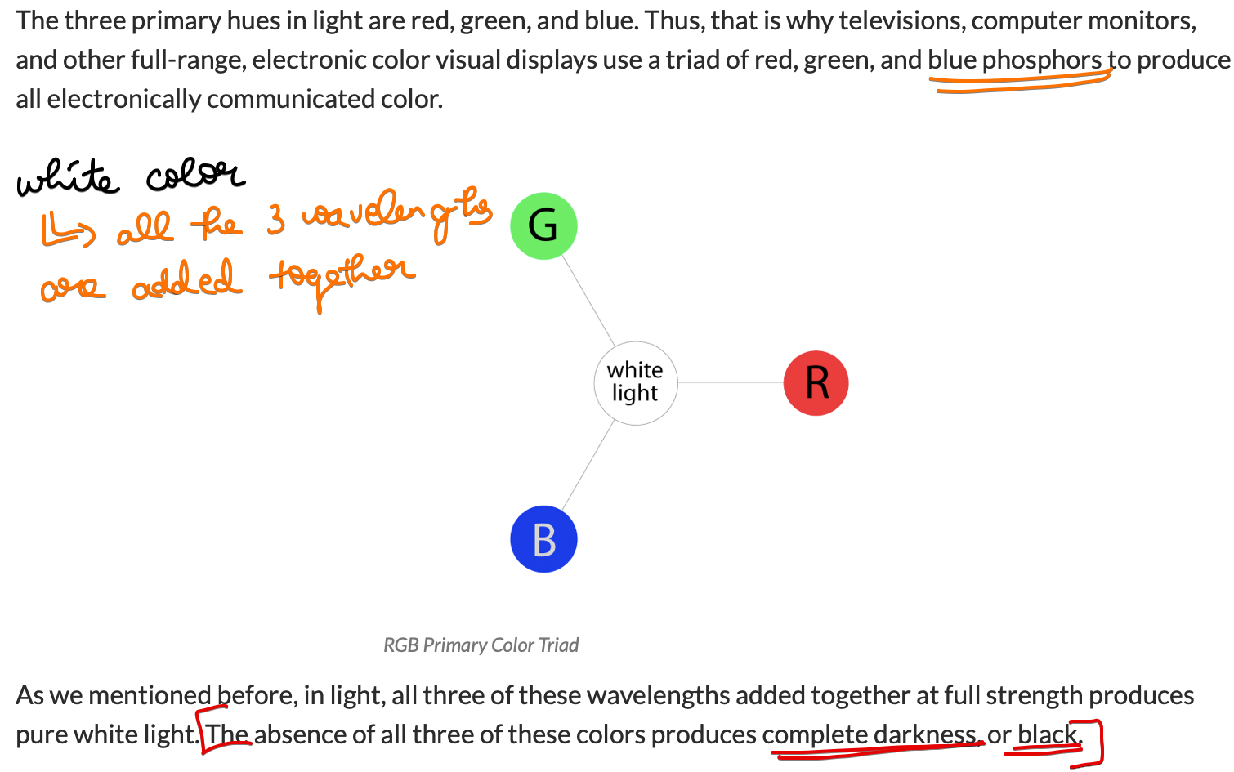

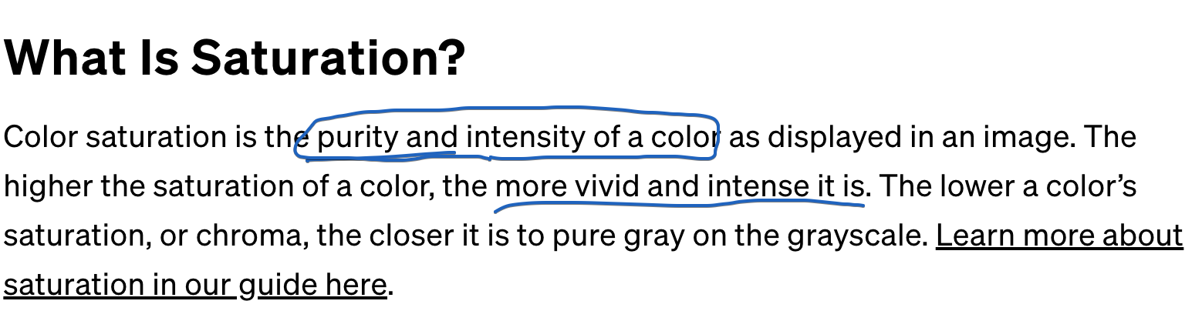

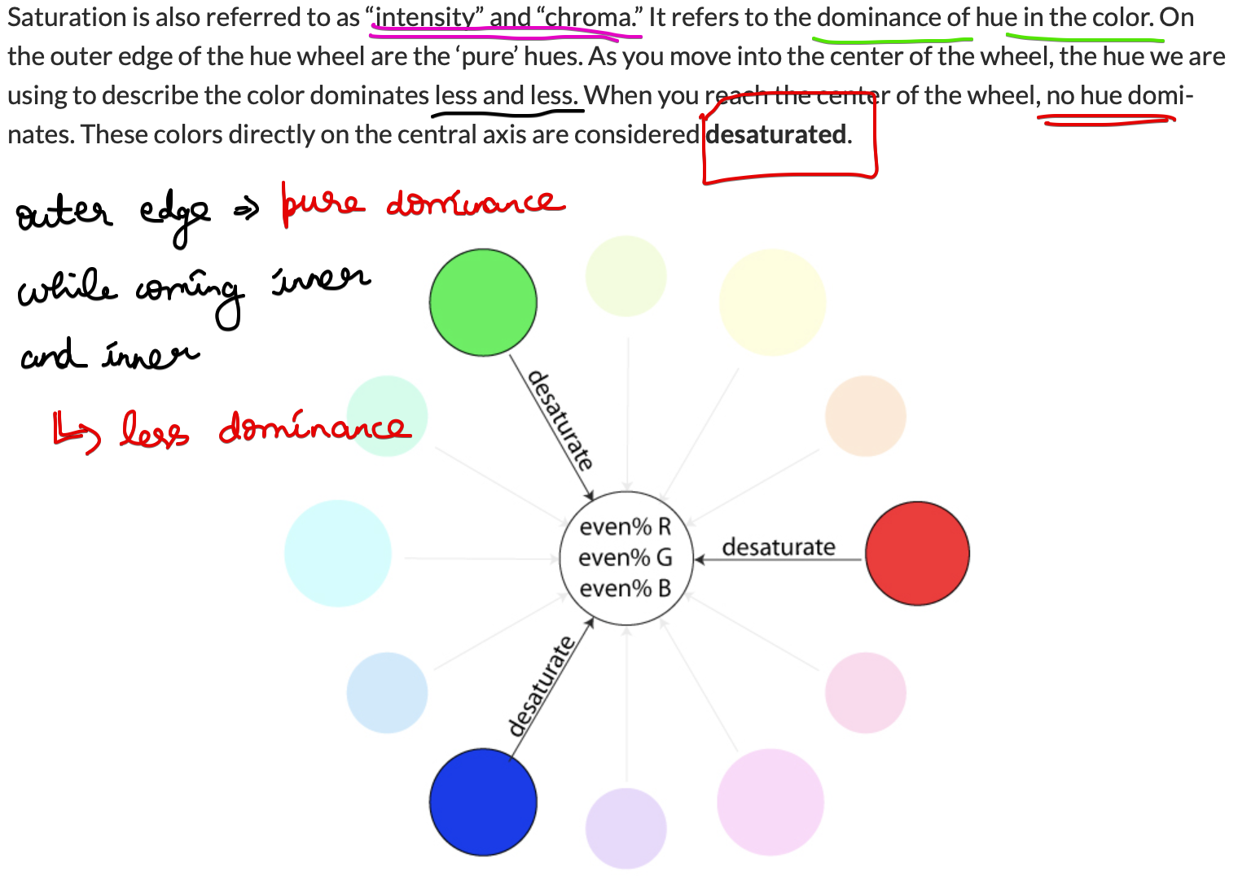  
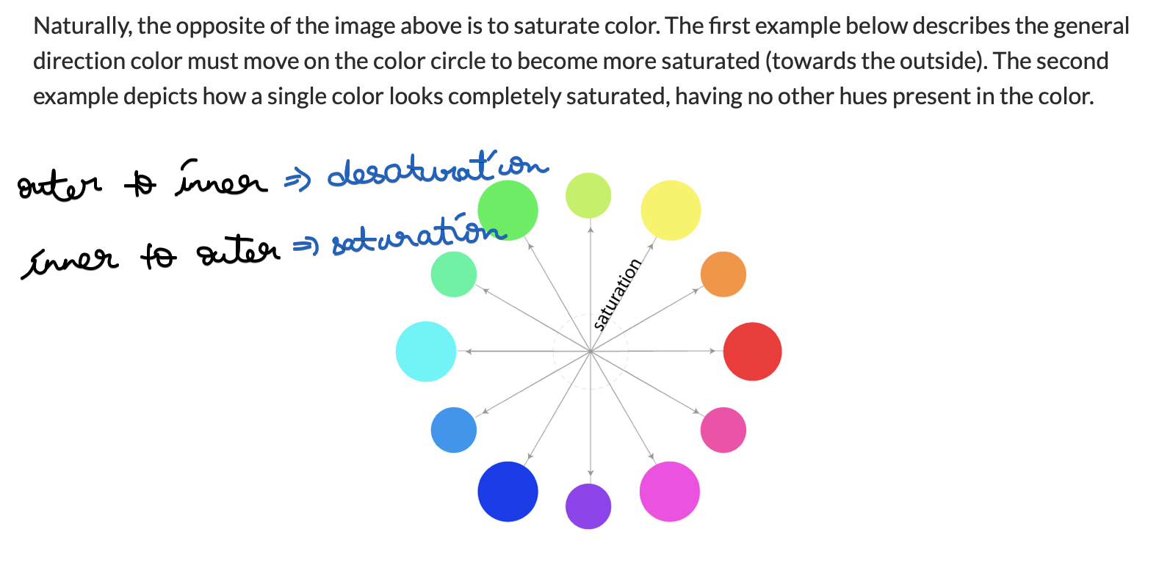  
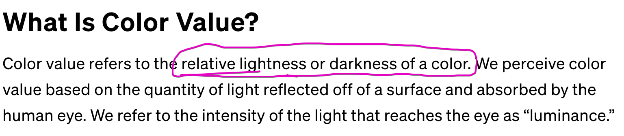  
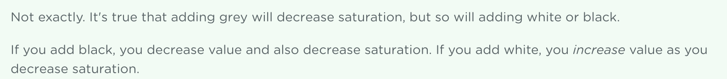

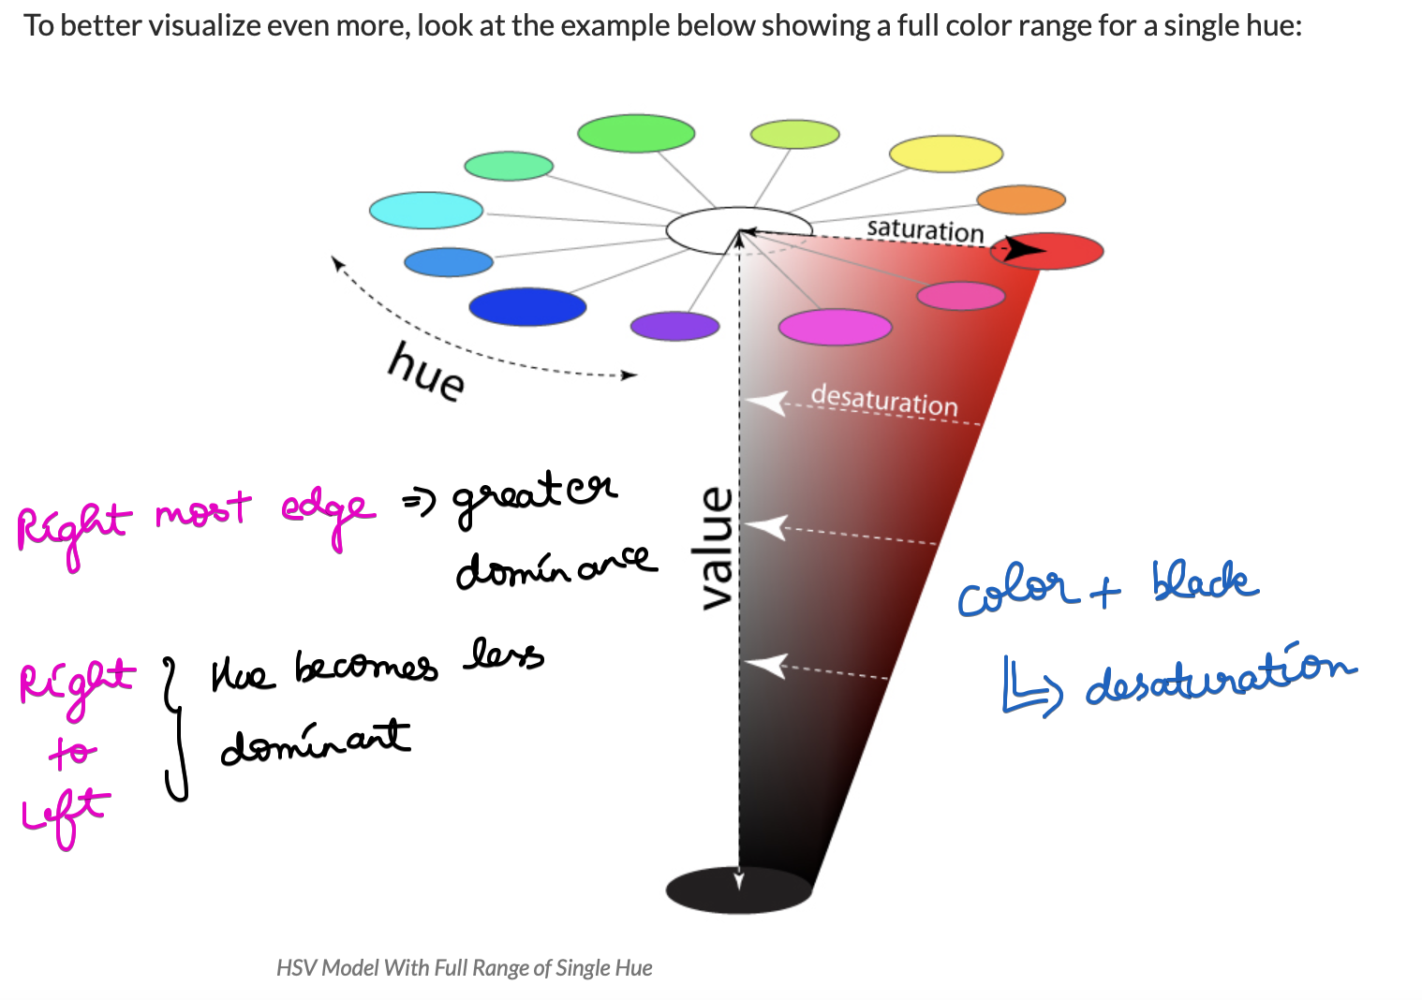

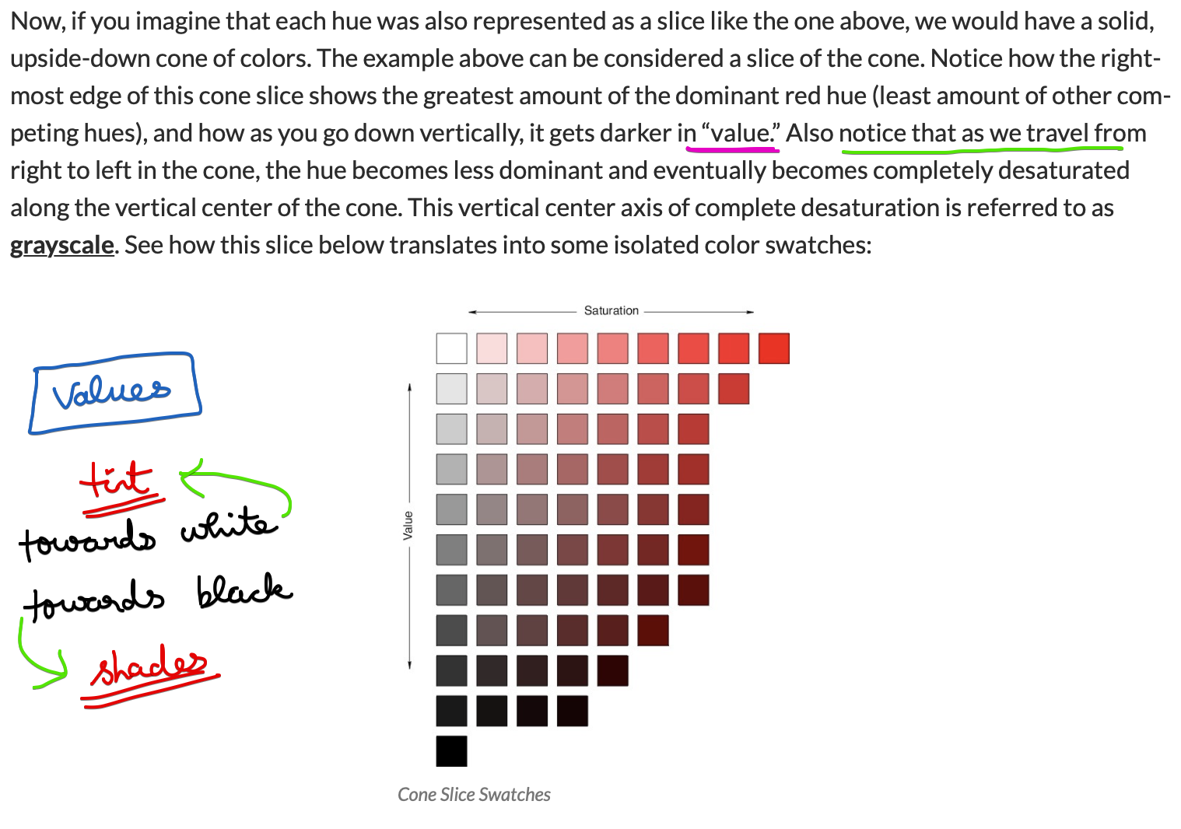

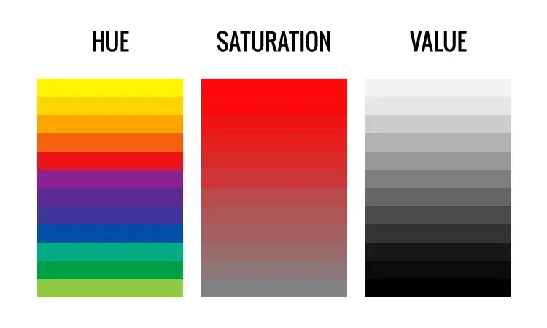

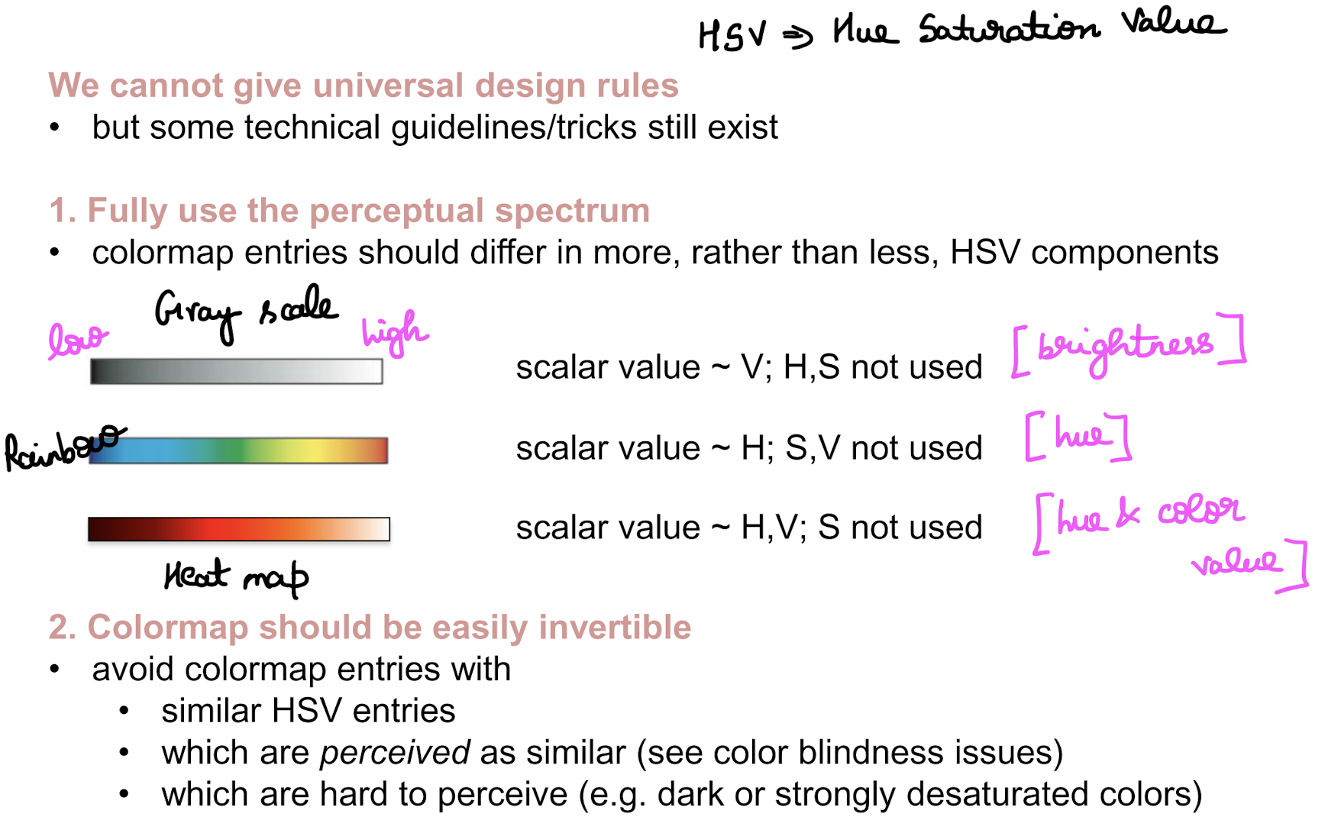

## **Colormap Design Techniques**

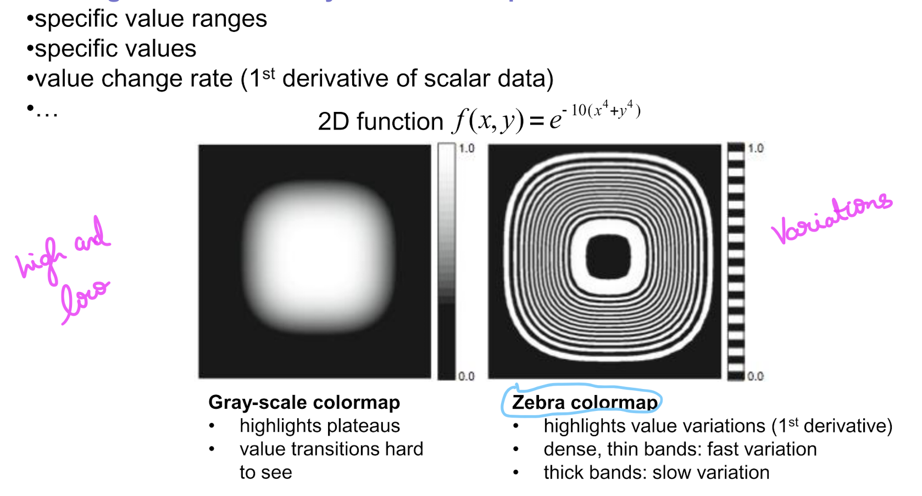

## **Colormap implementation Techniques**

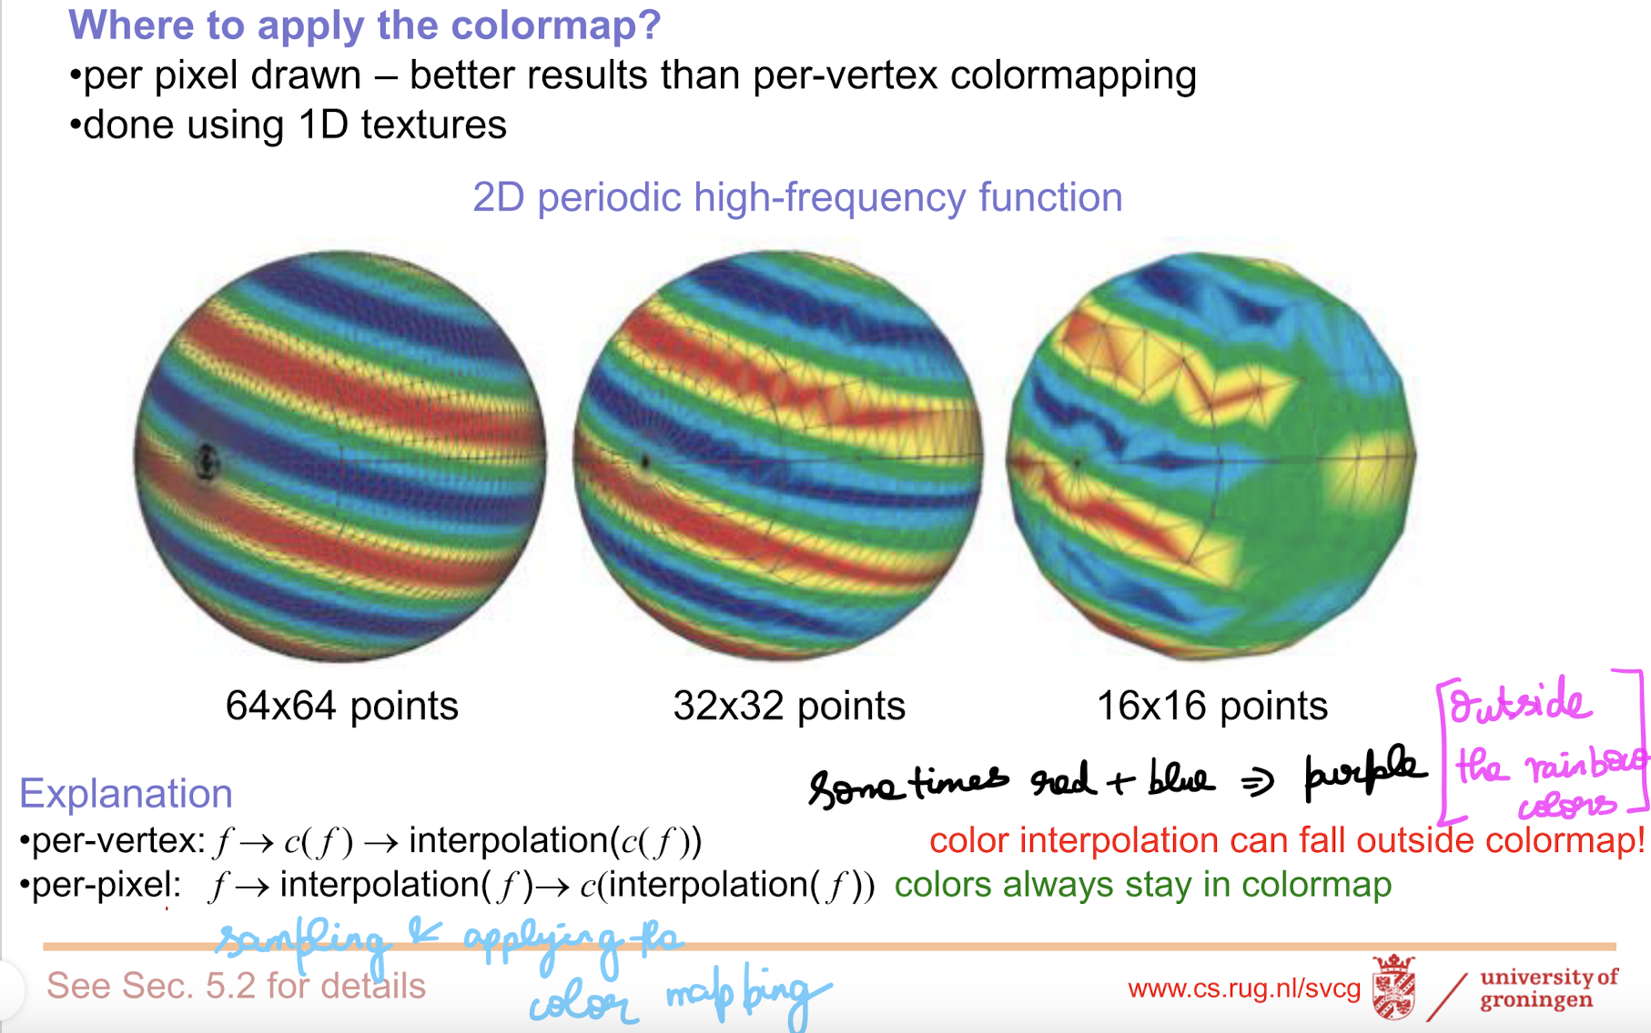

High sampling frequency 🡪 Mesh is smaller and colors are easily differentiable.

Low sampling frequency 🡪 Mesh is larger and the original function is not defined.

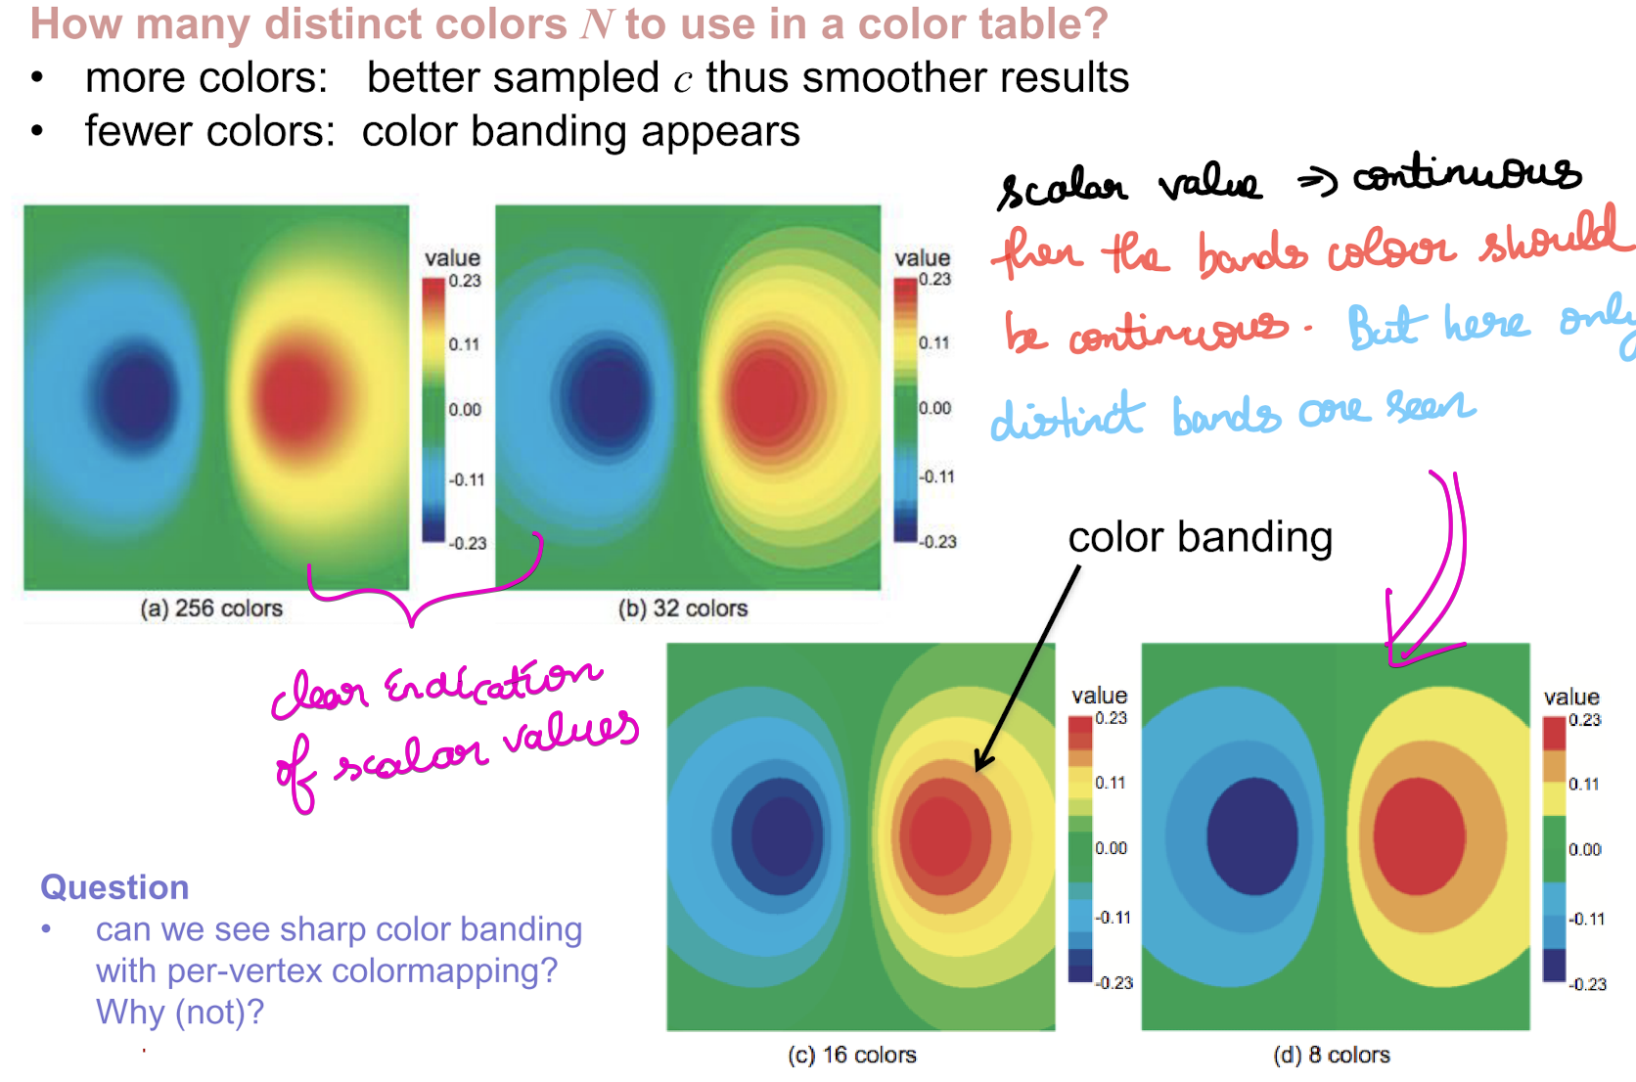

# **Contouring**

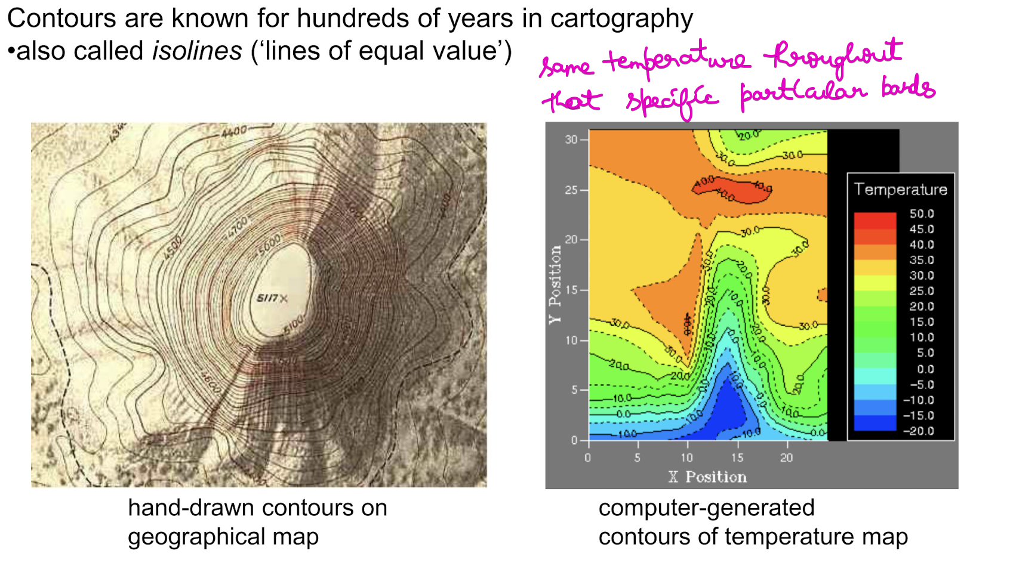

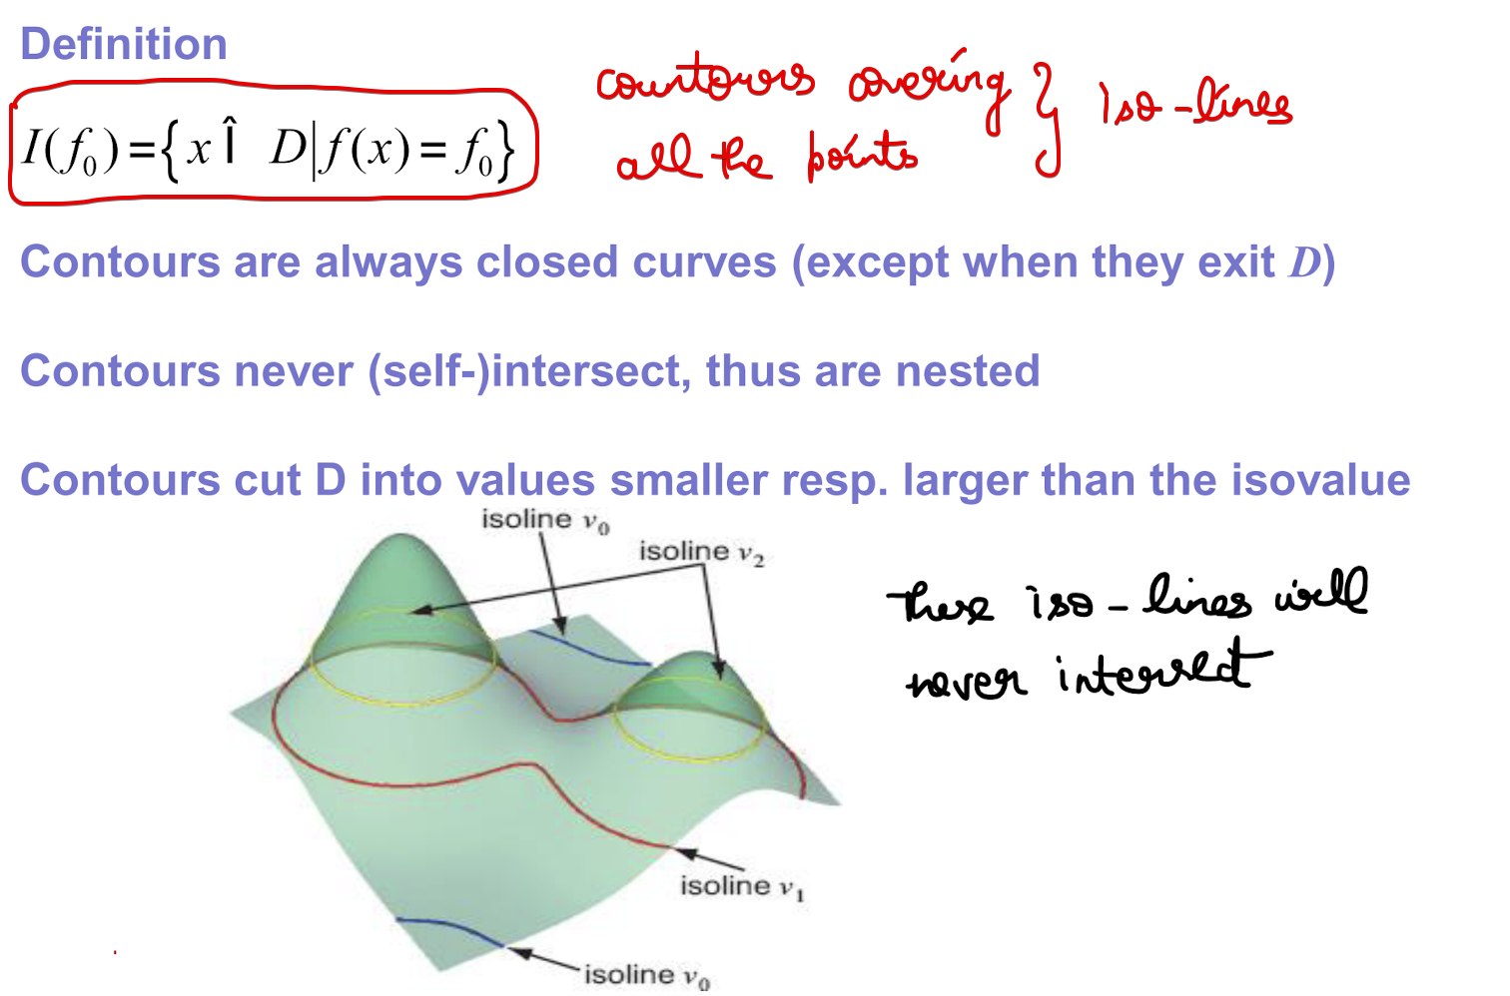

# **Height plots**

# **References**

<https://www.masterclass.com/articles/how-to-use-hsv-color-model-in-photography#what-is-saturation>

<https://learn.leighcotnoir.com/artspeak/elements-color/hue-value-saturation/>